OB CHEAT SHEET

UCG positive- needs to be seen within 24 hours; regular visit template, note G’sP’s/LMP/gestation/PMH etc; order Prenatal vitamins and iron, can order GC/Chlamydia. Place Ambulatory referral to OBGYN-internal, choose Initial OB, secure chat Lily Cortes or Josefina Sanchez.
NOB VISIT: Full H&P: G’sPs, OB history (year, NSVD/C section, GA-preterm? /Term/Induced, weight, complications), depression? Domestic violence? Miscarriages (spontaneous/therapeutic?)
Review
- Initial labs: CBC, Blood type +antibody, Gestation 1-hour glucose, HBsAg, Hep C, HIV, RPR w/reflex, Quant gold, UA with reflex to culture

- Ultrasound results – read everything! Re-date EDD if indicated. (See a table at page 2)
Perform:
  - Pap smear (if indicated) with GC/Chlamydia (21-29 y/o pap q 3 yr), 30 y/o pap with HPVq5 years or pap only q3 years.
  - Pelvic exam on all pregnant patients.
Order:
  - cfDNA (detects aneuploidies and gender)- order as early as 10 weeks.
No cut off; MA’s order in the portal; resident to order on EPIC code LAB10413
  - MSAFP (detects NTDs) – order 15-20 weeks 6 days; MA to order in the portal; resident to order on EPIC code LAB10399
  - GC/chlamydia swab/urine (swab preferred) if Pap is up to date or Pap not indicated.
  - Ultrasound for dating is usually ordered by MCOP during their initial OB intake. If needed, the code is 76801, if less than 14 weeks gestation or 76805 if more than 14 weeks gestation (this code is also for anatomical ultrasound)
Meds: PNV, Iron if indicated, Vit B6 if with nausea can combine with Doxylamine; ASA if indicated (check the table at page 2) and not CI.
*Low-dose aspirin (81 mg/day) prophylaxis is recommended in women at high risk of preeclampsia and should be initiated between 12 weeks and 28 weeks of gestation (optimally before 16 weeks) and continued daily until delivery. Those with at least 2 moderate risk factors are recommended to take LDA.
Counseling: weight gain, nutrition, alcohol, smoking, depression, safety, illicit drugs, birth control method, breastfeeding, etc

Follow up: every 4 weeks until 28 weeks' gestation with the same PCP or team. If not possible, patients may be seen by other teams but must be seen by the original team in future visits.
-Encourage delivery at KMC (SHOULD be asked for all visits).

Reassigning EDD based on date-ultrasound discrepancy.
Gestational age (weeks+days) based on LMP | Change LMP based EDD to US based EDD if US based gestational age differs from  LMP based gestational age by more than:
≤8+6 | 5 days
9+0 to 13+6 | 7 days
14+0 to 15+6 | 7 days
16+0 to 21+6 | 10 days
22+0 to 27+6 | 14 days
≥ 28+0 | 21 days

PREECLAMPSIA/PRETERM RISK FACTORS
HIGH RISK (Recommended LDA if the patient has 1 or more)
- History of preeclampsia
- Multifetal gestation
- Chronic Hypertension
- Type 1 or 2 DM
- Renal disease
- Autoimmune disease (SLE, Antiphospholipid syndrome)
- Combinations of multiple moderate-risk factors

MODERATE RISK (Consider LDA if the patient has more than one of these)
- Nulliparity
- Pre-gravid BMI greater than 30
- FamHx of preeclampsia (mother or sister)
- Black race (as a proxy for underlying racism)
- Lower income
- Age 35 or older
- Personal history factors (low BW or SGA, previous adverse pregnancy outcomes, more than 10-year pregnancy interval)
- In vitro fertilization

RECOMMENDATIONS FOR TOTAL AND RATE OF WEIGHT GAIN DURING PREGANNCY, BY PREPREGNANCY BMI

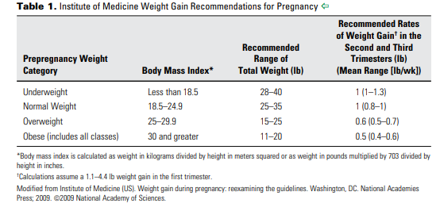
FOLLOW UP VISITS

15-22 WEEKS:
- review if cfDNA and MSAFP were done.
- Review/order Anatomical US (typically 19-22 weeks) – code 76805
- Refer to Perinatology: some common reasons
  - preterm delivery <36w- determine the reason for preterm delivery; refer to perinatology IF WITH significant hx like previous cerclage; check US report for cervical length, should be TVUS
  - AMA – 35 years and older- refer at 20 weeks
  - Positive prenatal screening tests – Patient needs to be sent to outside perinatologist – Valley Children’s (Madera or Visalia), or Los Angeles Perinatal Associates
24-28 WEEKS:
-Order:
- Third trimester labs: CBC, RPR w/ rflx, 1-hour GTT (if early trimester 1hr GTT was high w/ normal 3gtt or impaired, order ONLY 3hr GTT. Better to order at 26 weeks.
*Diagnose Gestational DM if 2 or more abnormal values. Order glucometer, strips and lancets, schedule with RD, give glucose log and bring at each visit with RD and provider, check sugar fasting and 4x/day (pre-breakfast and 1-2 hours after each meal and log. If the patient is not well controlled and requires Insulin, transfer to KM as HROB. Send a secure chat to Bristi-Anna Arana.
- Rescreen Chlamydia (may include Gonorrhea) in High-risk groups.
- Repeat Rh (D) antibody if Rh negative- at least within 72 hours to 7 days without bleeding before giving Rhogam
-Follow up - every 2-3 weeks after 28 weeks until 36 weeks.
- WEEKS:
-Tdap (optimal 27-36 weeks), given at every pregnancy regardless of immunization status.
- WEEKS:
-Rh neg mothers WITH Negative Abs: Administer Rhogam 300mcg IM x1 28w then postpartum within 72 hours if baby is Rh positive.
-sign BTL form if desired BTL and scan to patient’s chart.
-check for fetal presentation via bedside US or Leopold
-to be seen at CCC 1 time if delivering at BMH and schedule back to EN for future visits. CCC can keep the following patients who need to keep an eye on (i.e TOLAC, repeat C section). Operative records should be available for those that had previous C section. If there is none, the patient should be transferred out to KM High risk.
36WEEKS:
- GBS swab
- GBS bacteriuria needs GBS prophylaxis antepartum and no need to perform swab.
- HSV prophylaxis- see the table below for antiviral medications.
- Clinical history of genital herpes: offer suppressive viral therapy at or beyond 36 weeks of gestation. For primary outbreaks that occur in the third trimester, continuing antiviral therapy until delivery may be considered.
- Cesarean delivery is indicated in women with active genital lesions or prodromal symptoms, such as vulvar pain or burning at delivery, because these symptoms may indicate viral shedding.
- NST/BPP- Please see tables on page 5-7 for antenatal testing recommendations.
- Order Growth scan (code IMG537) for patients delivering at BMH, otherwise, schedule under POCUS.
-Medical indications for timing of deliveries. See tables on page 8-9.
- Bedside US for presentation, EFW, AFI (can be done weekly until EDD)
- Discuss Contraception options postpartum, Breast feeding, Educate about labor precautions and kick counts, pain control intrapartum options
-Disability- 6 weeks after NSVD pr 8 weeks in C section. The patient should complete her portion first then give it to MCOP to fill out the rest. Attendings must sign the form.
Follow up appointment weekly after 36 weeks' gestation
37WEEKS:
-Give patient OB records with GBS culture results.
40WEEKS:
-Perform cervical exam, Bishop score, EFW, presentation
-Induction of labor (code 162674) referral at BMH requires cervical exam, presentation, EFW, and bishop score, but not required for KM. Complete KM induction form and take to medical records for processing.
-Referral for NST (code REF423) (indicate KM or Memorial and reason, BPP with NST, indicate if weekly or biweekly) prior to induction. Referral forms should be filled out and sent to medical records person for same day scanning to the patient’s chart.

Code | Procedure/Encounter
IMG530-76801 | OB ultrasound less than 14 wks
IMG532-76805 | OB ultrasound greater than 14 wks (anatomical scan)
IMG536-76815 | OB ultrasound, Limited (Growth scan, AFI, Placenta Loc, Fetus Position)
IMG537-76816 | OB ultrasound, Follow up (Growth scan with abnormalities, Anatomy FU)
REF423 | Ambulatory referral for Fetal NST
162672 | Ambulatory Referral for Perinatology-MFM, Transfer of care
REF50 | Ambulatory referral to Nutrition services- choose CPSP
REF32 | Pregnancy IV Iron
162674 | Ambulatory Referral for Delivery – IOL or C section
158669 | Referral for GYN (Surgery)
REF29 | Referral to GYN/ONC
Add comments on referral – ordering what & why
Dx code
 | Primigravida
Z34.01 | Encounter for supervision of normal first pregnancy, first trimester
Z34.02 | Encounter for supervision of normal first pregnancy, second trimester
Z34.03 | Encounter for supervision of normal first pregnancy, third trimester
 | Multigravida
Z34.81 | Encounter for supervision of other normal pregnancy, first trimester
Z34.82 | Encounter for supervision of other normal pregnancy, second trimester
Z34.83 | Encounter for supervision of other normal pregnancy, third trimester
 | Billing
0500F | Initial prenatal care visit
0502F | Subsequent prenatal care visit
0503F | Postpartum care visit

HSV ANTIVIRAL MEDICATIONS
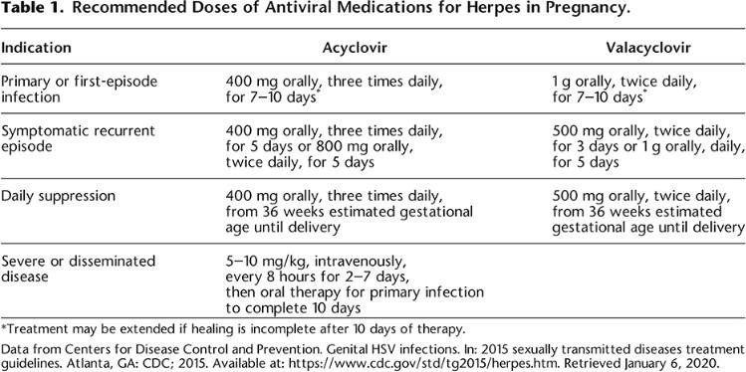

ANTENATAL SURVEILLANCE RECOMMENDATION
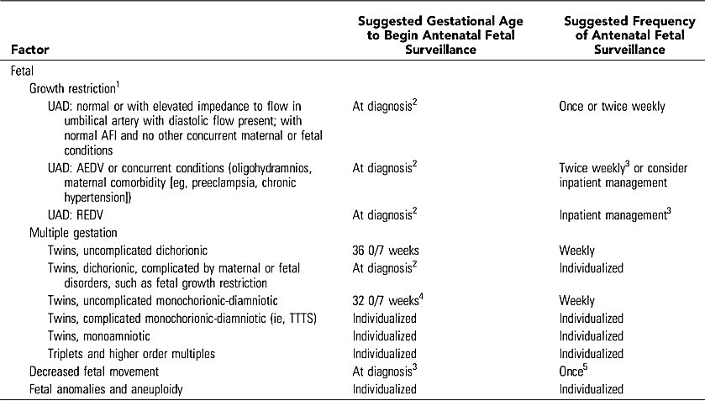

ANTENATAL SURVEILLANCE RECOMMENDATION CONTINUED….
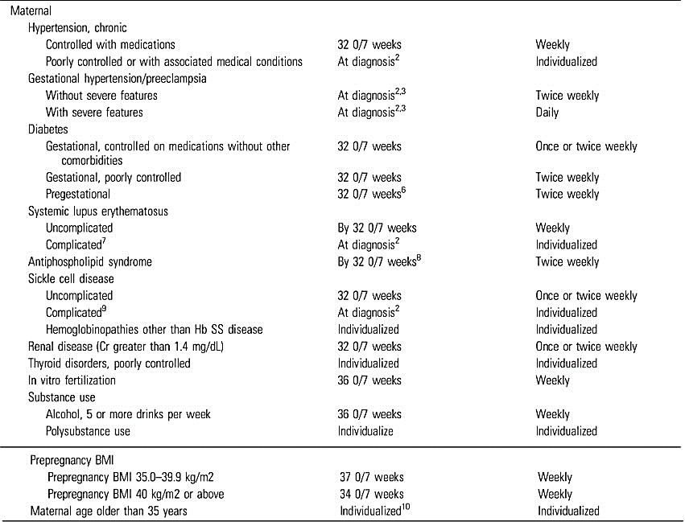

ANTENATAL SURVEILLANCE RECOMMENDATION CONTINUED…
